**READ ME.**

**MATLAB File Name:** Piezo1_mSMC_Calcium_Influx

**MATLAB version:** Matlab2020a (or more recent)

**Programming language**: MATLAB

The code described in this document should be used for research purposes only and is currently available through the following links.

* <https://github.com/ydu1955/Piezo1_mSMC_Calcium-Influx/tree/MATLAB_Piezo1_YD>
* DOI: 10.5281/zenodo.6282081 (MIT License)

**Installation and use instructions:**

This code was written using a student license for MATLAB 2020a and installation instructions can be found through MathWorks website. The Symbolic Math Toolbox will also need to be downloaded after MATLAB is installed. The file can then be added to MATLAB pathway and opened in editor for use.

Green line commentary text is available for each section of code and variable that needs to be adjusted/changed both at the beginning of every section and for relevant lines. The file referenced by the code must be in “.txt” format and data sorted in the first 2 columns without labels, time and intensity, respectively. Crucial lines to note are listed below.

* The text file’s name must be changed in lines 18-20
* Line 53 for baseline calculation and line 54 for manual input (remember to disable line 54 if you decide to calculate baseline).
* Line 55 to adjust datapoint detection for peak bases (typically between 0-0.1)
* Line 65 to adjust cutoff multiplier to determine threshold for peaks (typically a value between 1.0-1.5)

When everything is ready, the calculated variables and arrays for the time and intensity can be exported as an “.xls” file. Column and sheet number can be changed as needed. There are no labels in exported file, reference Lines 219-229 from MATLAB code for column labels.

Please note, this code has not been submitted for community commenting and input.

**Description:**

The key operations of the code are identifying peaks in mSMC calcium influx signaling. First, the baseline is identified through manual input or by calculating the lowest average after dividing the curve into small segments, see Installation/use instructions for more details. Next, a multiplier is used to mark a threshold where data points above this threshold are filtered using loops to find peaks. Datapoints left and right of peak datapoint are filtered using loop conditions to estimate where peak bases are. Peaks, peak bases, and baselines are graphed in a figure for confirmation. All data points are saved in separate arrays where they can be used to calculate the intensity change, time between calcium spikes, time duration of peaks, frequency, and roughly estimate the area under the curve. This code is best used for calcium curves with low background noise and relatively cleaner curves. Messier curves or curves with sloping baselines might require manual deletion/manipulation of data points from the original curve without biasing the final calculated variables.

**Example Data**

The following is a sample of our mSMC PiezoWT calcium influx signal data with a figure to demonstrate the primary function of the code. Numerical values calculated based on the arrays generated (visualized in the figure) are exported in a separate “.xls” file.

File name: Example_mSMCs_WT_04.txt (included below)

Adjusted Lines:

* **Lines 18-20:** Example_mSMCs_WT_04.txt
* **Line 54:** 556
* **Line 55:** 0.03
* **Line 65:** 1.255

**Figure:**

**Blue Curve:** Original curve exported from zeiss software

**Purple Curve:** Baseline

**Orange Curve:** Identified peak datapoints

**Yellow Curve:** Identified peak and peak base datapoints

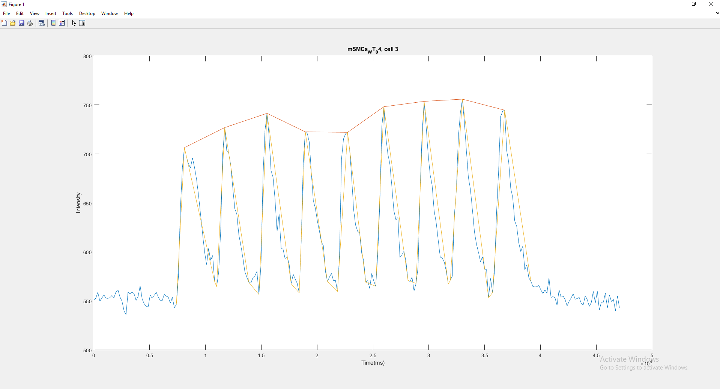

Example_mSMCs_WT_04.txt

0 551.0967742

180.0103 552.7741935

361.0206 558.9677419

541.0309 549.8709677

721.0412 552.8064516

902.0516 556.2903226

1082.0619 552.9354839

1262.0722 552.6774194

1443.0825 553.3870968

1623.0928 555.6451613

1804.1032 553.2903226

1984.1135 559.1935484

2164.1238 561.4516129

2345.1341 553.9677419

2525.1444 549.8709677

2705.1547 540.0322581

2886.1651 536.0967742

3066.1754 559.2580645

3247.1857 557.0322581

3427.196 559.1290323

3607.2063 557.4193548

3788.2167 550.516129

3968.227 554.5806452

4148.2373 565.3548387

4329.2476 552.1290323

4509.2579 547.2258065

4689.2682 544.483871

4870.2786 544.1290323

5050.2889 556.0322581

5231.2992 552.6774194

5411.3095 555.8064516

5591.3198 558.8387097

5772.3302 554.1290323

5952.3404 550.2903226

6132.3507 550.483871

6313.3611 556.9354839

6493.3714 554.9032258

6673.3817 553.9677419

6854.392 547.7419355

7034.4023 553.7741935

7215.4127 543.1612903

7395.423 546.5483871

7575.4333 574.3548387

7756.4436 644.3870968

7936.4539 686.0967742

8116.4642 706.3548387

8297.4746 696.9032258

8477.4849 690

8658.4952 685.6129032

8838.5055 695.8064516

9018.5158 686.2258065

9199.5262 674.4193548

9379.5365 657.6451613

9559.5468 638.5483871

9740.5571 618.6129032

9920.5674 600.1935484

10100.5777 587.1935484

10281.5881 603.5806452

10461.5984 591.4193548

10642.6087 596.4193548

10822.619 569.6774194

11002.6293 564.6774194

11183.6397 579.3548387

11363.65 621.9032258

11543.6603 699.6129032

11724.6706 726.8387097

11904.6809 703.2580645

12085.6913 700.516129

12265.7016 688.6129032

12445.7118 665.4516129

12626.7222 644.1612903

12806.7325 638.7741935

12986.7428 617.7741935

13167.7531 606.8387097

13347.7634 594.2258065

13527.7737 579.9354839

13708.7841 574.0967742

13888.7944 568.8387097

14068.8047 568.3225806

14249.815 573.7419355

14429.8253 575.6129032

14610.8357 580.3225806

14790.846 556.5806452

14970.8563 586.483871

15151.8666 675.7741935

15331.8769 723.7419355

15511.8872 741.3870968

15692.8976 718.4516129

15872.9079 682.9677419

16053.9182 676.1290323

16233.9285 653.2580645

16413.9388 620.7419355

16594.9492 639

16774.9595 604

16954.9698 602.6451613

17135.9801 592.6451613

17315.9904 594.7741935

17496.0007 587.7741935

17677.0111 567.516129

17857.0214 577.1290323

18038.0317 572.4516129

18218.042 567.9677419

18398.0523 558.1935484

18579.0627 611.1612903

18759.0729 691.6129032

18939.0832 722.483871

19120.0936 720.7741935

19300.1039 711.9032258

19481.1142 680.8387097

19661.1245 652.3548387

19841.1348 644.6129032

20022.1452 631.516129

20202.1555 621.5483871

20382.1658 610.0645161

20563.1761 606.3870968

20743.1864 580.3548387

20923.1967 569.9032258

21104.2071 574.3870968

21284.2174 578.1290323

21464.2277 570.7096774

21645.238 570.9677419

21825.2483 559.5483871

22006.2587 596.8387097

22186.269 694.7419355

22366.2793 715.3870968

22547.2896 720.3870968

22727.2999 721.9677419

22907.3102 704.5483871

23088.3206 677.4193548

23268.3309 643.1612903

23449.3412 627.3225806

23629.3515 621.0645161

23809.3618 619.3225806

23990.3722 598.9032258

24170.3825 591.0322581

24350.3928 569.1612903

24531.4031 570.8064516

24711.4134 562.8387097

24892.4238 578.1290323

25072.4341 570.4193548

25252.4443 564.9677419

25433.4547 598.2580645

25613.465 649.0967742

25793.4753 727.4193548

25974.4856 748.0967742

26154.4959 717.4516129

26334.5062 700.0322581

26515.5166 689.5483871

26695.5269 666.483871

26876.5372 641.8709677

27056.5475 632.7096774

27236.5578 635.1935484

27417.5682 594.3870968

27597.5785 597.2258065

27777.5888 600.7419355

27958.5991 590.4193548

28138.6094 571.0645161

28319.6198 569.9354839

28499.6301 574.2580645

28679.6404 560.2580645

28860.6507 567.8709677

29040.661 584.8064516

29220.6713 660.7419355

29401.6817 720.9677419

29581.692 753.5806452

29761.7023 728.1290323

29942.7126 699.9677419

30122.7229 678.7741935

30302.7332 667.8709677

30483.7436 641.5806452

30663.7539 630

30844.7642 612.1935484

31024.7745 594.7419355

31204.7848 593.7741935

31385.7952 589.7419355

31565.8055 580.483871

31745.8157 567.1935484

31926.8261 571.0967742

32106.8364 575.3548387

32287.8468 637

32467.857 662.1290323

32647.8673 716.7096774

32828.8777 741.6451613

33008.888 755.8387097

33188.8983 732.5483871

33369.9086 703.3548387

33549.9189 675.8387097

33729.9292 663.8064516

33910.9396 642.9032258

34090.9499 620.3870968

34271.9602 607.9354839

34451.9705 599.516129

34631.9808 589.9677419

34812.9912 595.1935484

34993.0015 582.6129032

35173.0118 581.8387097

35354.0221 553.2580645

35534.0324 573.0322581

35715.0428 558.6129032

35895.0531 581.5483871

36075.0634 641.1290323

36256.0737 683.0645161

36436.084 738.0967742

36616.0943 743.4193548

36797.1047 744.5806452

36977.115 703.4516129

37157.1253 691.8709677

37338.1356 665

37518.1459 655.6451613

37698.1562 631.6129032

37879.1666 625.8709677

38059.1769 609.4193548

38240.1872 600.2580645

38420.1975 605.9677419

38600.2078 581.8387097

38781.2182 586.8064516

38961.2284 573.6129032

39141.2387 570.1935484

39322.2491 564.7741935

39502.2594 564.4193548

39683.2697 564.6451613

39863.28 565.9677419

40043.2903 561.1290323

40224.3007 557.5806452

40404.311 561.4193548

40584.3213 557.9354839

40765.3316 573.5483871

40945.3419 553.6774194

41125.3522 554.483871

41306.3626 553.2258065

41486.3729 545.3870968

41667.3832 561.4193548

41847.3935 553.8709677

42027.4038 555.1935484

42208.4142 551.5483871

42388.4245 544.9354839

42568.4348 549.6774194

42749.4451 553.0967742

42929.4554 557.2903226

43110.4658 551.7741935

43290.4761 552.5483871

43470.4864 553.6451613

43651.4967 547.7419355

43831.507 545.9032258

44011.5173 555.3870968

44192.5277 551.3225806

44372.538 544.5483871

44552.5483 548.1935484

44733.5586 559.8387097

44913.5689 548.0967742

45094.5793 560.0322581

45274.5896 540.8387097

45454.5998 548.9354839

45635.6102 548.6774194

45815.6205 558.1612903

45995.6308 542.9032258

46176.6411 556.0967742

46356.6514 549.516129

46536.6617 551.7096774

46717.6721 540

46897.6824 555.1290323

47078.6927 542.8064516